Screen 1 : With Image ,Social Media icon and up arrow icon

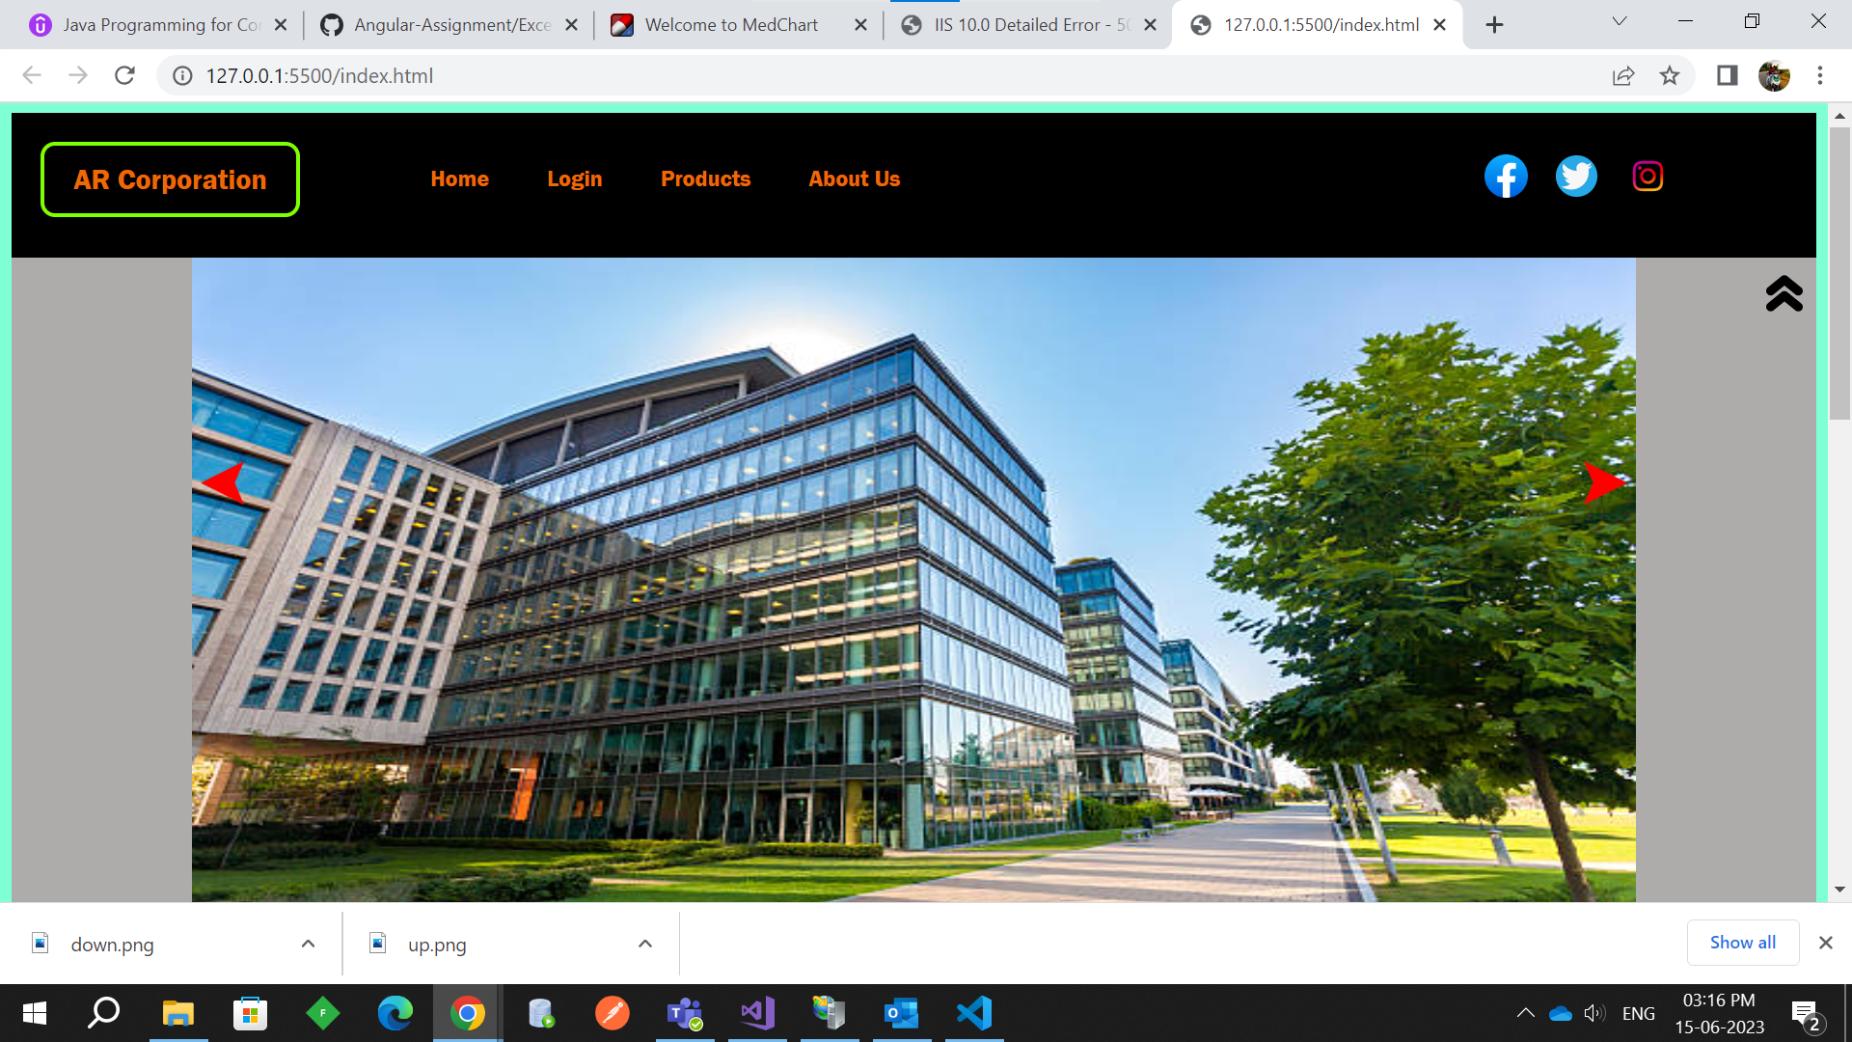

Screen 2 : With image hidden and displaying the service box

Screen 3 : With Service box and footer

Screen 4 :

